Analytics Report Critique
Business understanding
  - Background
The report, ‘don-t-know-why-employees-leave-read-this’, seeks to understand the reasons that lead to employees leaving the company base on several feature variables. These features include job satisfaction, performance evaluation, number of projects that employee involve etc. In this critique, my task is to critically analyse the report which is provided by the data scientist team and compare it with my own set of visualizations and models. I will first begin with business understanding, which demonstrates my knowledge about the area. Then, I will demonstrate my data understanding and data preparation. Lastly, I will be creating models and evaluate them such that they can be developed in the future.
  - Data mining goals
To understand why employees are leaving the company, one approach would be to use data analytics. Data analytics would be suitable because the whole report provided involves the process of collecting and organizing raw data and draw insightful inferences. By using the collected and organized data, it would help me and the company leader to understand critical and crucial factors that lead to employees leaving the company. Furthermore, suggestions and improvements can be provided after understanding the most critical factors.
  - Initial Assessment
Even though data analytics is a helpful tool in gaining insights, several limitations are surrounding the cost and ethics aspect. The first issue relates to the time cost and financial cost. Creating a survey and a database to keep track of employee’s performance and feedback takes a lot of time. It takes time to get feedback from employee and some employees refuse to answer the questionnaire. It also takes time for the data analyst to organise and clean up the data. These 2 factors make up the financial cost which might cost a burden to the company. The second issue relates to the data ethics and data privacy aspect. The analysis should comply with regulations, ensuring a fair representation of social groups, and not using the data for other purposes.
On the bright side, data analytics helps a lot with the decision-making process. Firstly, data analytics helps the company’s leadership to create long-term strategies through the understanding of data points. Compare to traditional methods, the process of finding the problem would take a lot of time that makes the process inefficient. Secondly, data analytics’ strength lies in the easiness of classification. When dealing with data, clusters and classification are often used to summarise the data such that patterns can be observed. Traditional methods, on the other hand, takes a lot of time in classifying data and human errors are often involved in the process.
Data Understanding
  - Initial data collection
The dataset of the report came from a response of 14,999 employees. For each response, the data science team uses 8 numerical features and 2 categorical features to test out the reasons why employees leave the company.
  - Data description analysis
There a few limitations regarding to the feature variables. For example, the ‘number of projects employee worked on’, did not state whether the unit of measurement is base on per month or year. Lacking out such an important detail might lead to a waste of time in researching in-depth about the problem. Furthermore, the report misses employee orientated variables. For experiences relating to the employee inside the company, they should include a) satisfaction reasons in the company b) How many breaks do each employee have. These 2 key features explore the employee’s psychological aspect. For experiences relating to the employee outside the company, they should include a) How did family matters impact the employee’s decision in leaving the company b) what is the salary that other companies are giving to the employee. These 2 key features related to family conditions and competitors’ condition. Missing these key variables would not be effective in finding the key problem.
  - Data exploration analysis
In this section, I will be adding 2 new visualizations to explore the dataset, they are the survival analysis and the hazard ratio chart. I have proposed these 2 new visualizations because the survival analysis shows the period of employees remaining in the company, while the hazard ratio chart demonstrates features that are crucial in leading to employees leaving the company.
To create the survival analysis, I will be using columns such as time_spend_company, left, and salary. The visualization will be created by comparing the dependent variables, time_spend_company and left, upon the independent variable, salary, based on the high, medium, and low salary (see Appendix A).
To create the hazard ratio chart, I will first break down the column salary into 3 high, medium, and low dummy columns. The visualization will be created by comparing the dependent variables time_spend_company and left, upon the independent variables such as satisfaction level and last evaluation (see Appendix B).

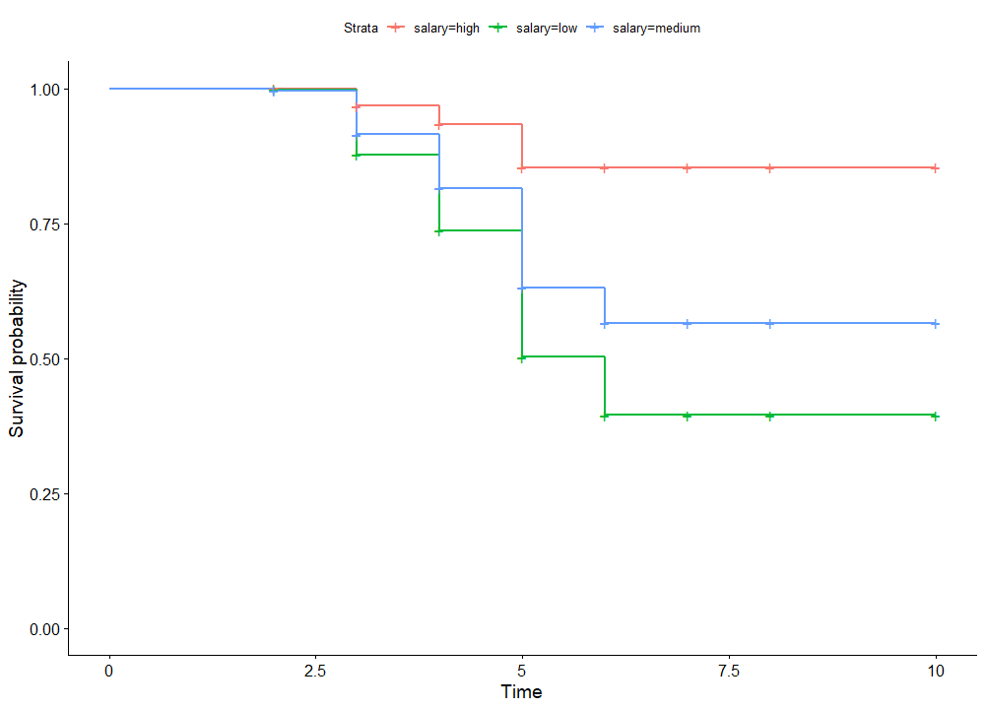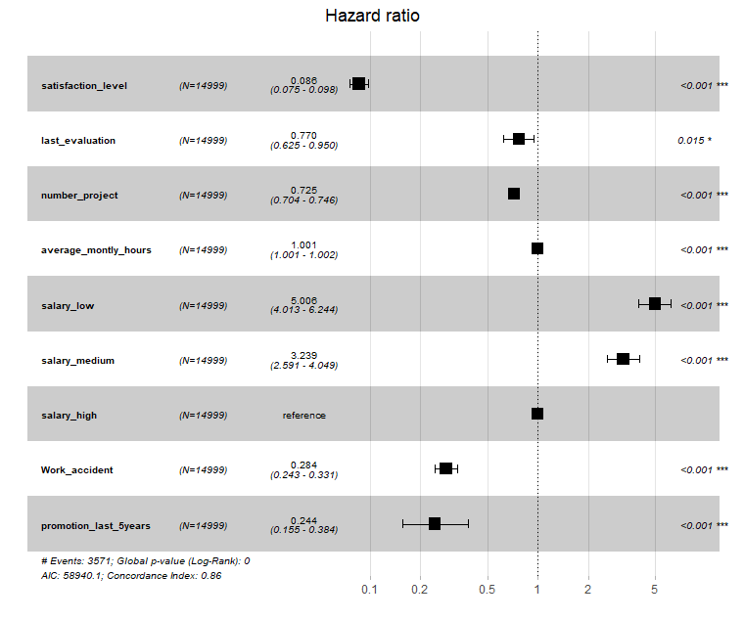
The survival analysis shows that employees who have lower salary have a higher probability of leaving the company faster, while employees who have a higher salary have a high probability of staying in the company for a longer period. Interestingly, the visualization demonstrates that less than 50% of the low salary employees would remain in the company after working for 6 or more years. Base on this perspective, it seems that salary plays a strong factor for employees determining to leave the company.
If we take a high salary as the reference point, the hazard ratio chart shows that work accidents, promotion last 5 years, satisfaction level number of projects, last evaluation have a hazard ratio of less than 1, this means that these factors have a smaller risk of leading employees in leaving the company. On the other hand, medium and lower salary have a hazard ratio bigger than 1, suggesting that these factors have a higher risk of leading employees in leaving the company. The variable, average monthly hours, would be insignificant to determine the hazard ratio. This might be caused by employees in high salary generally have an equivalent higher monthly hour, thus it is impossible to determine whether it affects high salary employees in leaving the company.
Due to word constraints, this exploration only uses high salary as the reference point for hazard ratio, further analysis should also be conducted using medium salary and low salary as a reference point.
  - Verify data visualization quality
During the process of creating my visualization, I found out that there are a few issues with the visualizations made by the data scientist team. For example, the histogram in section 3 would be chart junk. The variety of colours to represent each bar is unnecessary and easily distracts the viewer from understanding the report.
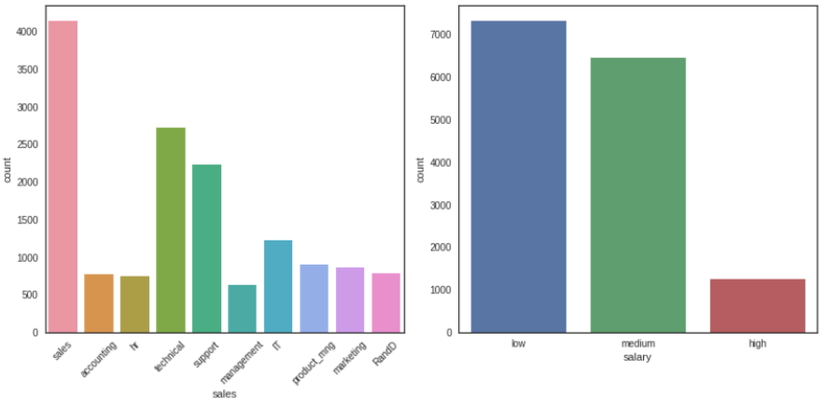
To effectively build the narrative of the report, I have decided to create a new histogram that removes the colours and arrange them in descending order as shown below.
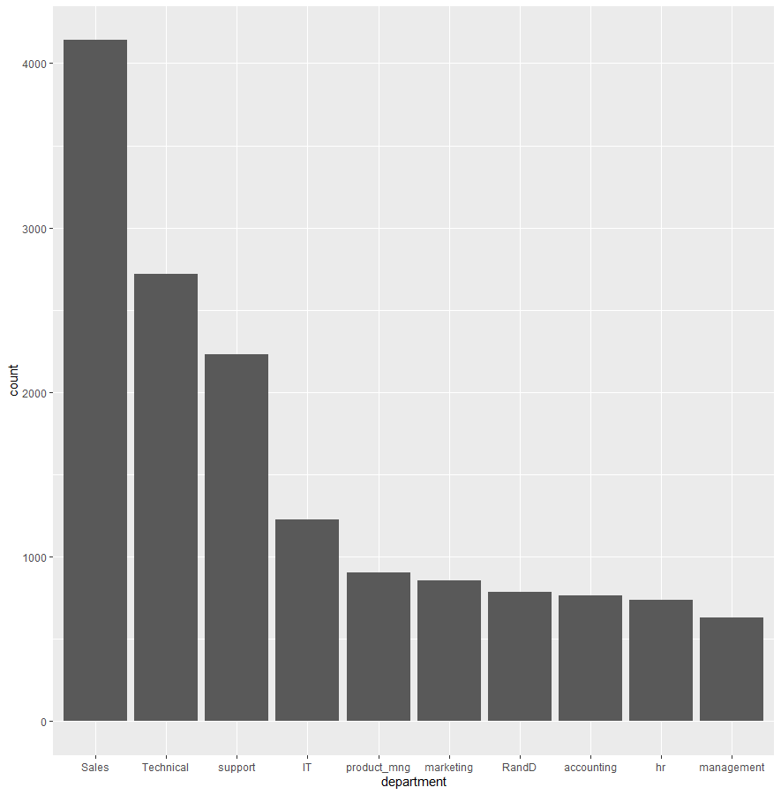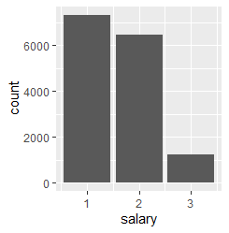
Another issue relates to the selection of variables for the PCA plot in section 3. Firstly, the data scientist team did not state which features they are using to create the PCA plot, even so, they should clearly state it either on the graph or below the graph. Secondly, the data scientist team only selects 2 features and leaves out other features. An unclear delivery of plots makes it harder and ineffective for the company’s top management to understand the visualization.
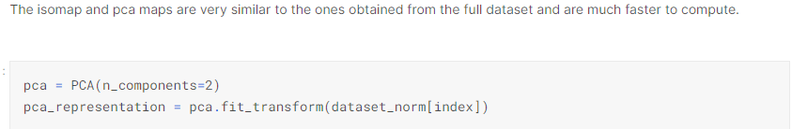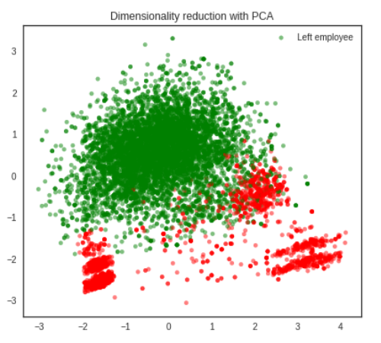
One solution would be to combine the PCA score plot and loading plot to create a PCA bi-plot, as shown below. I have also added labels to the PCA bi-plot to increase the easiness of reading the visualization.
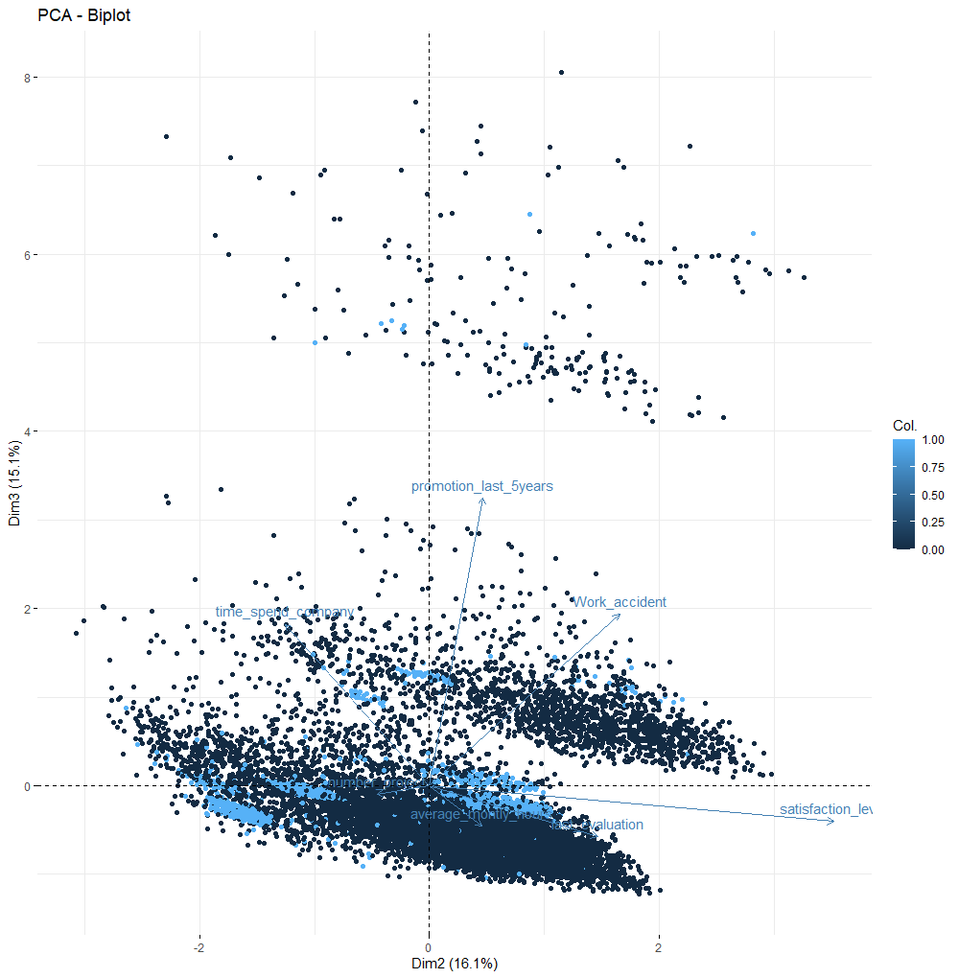
There are several interesting findings derive from this PCA bi-plot. For example, this new PCA bi-plot suggest that satisfaction level would be quite positively correlated with last evaluation. On the other hand, the PCA bi-plot suggest that satisfaction level would be negatively correlated with time spent in the company.
Data Preparation
  - Dataset description analysis
A compliment should be made regarding checking for missing values before proceeding to the next step. However, the most important step that the data science team miss is to complete a duplication check. To solve this issue, I decided to find out the average mean duplicates and plot them in a bar chart. I choose this method because it is the easiest way to visualize the number of duplicates in the dataset.
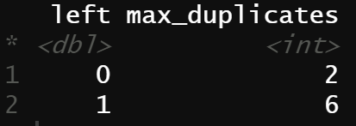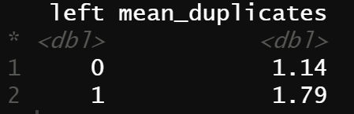
Base on the findings of the dataset, the maximum amount of duplicates for employees who did not leave the company (remainers) is 2, while the maximum amount of duplicates for employees who left the company (leavers) is 6. In addition, the duplicates for remainers have a mean of 1.14, while the duplicates for leavers have a mean of 1.79. Base on this explanation, if the data scientist did not remove the duplicates, the results tend to be biased to leavers than remainers. In other words, to express in terms of probability, the existing dataset has a higher chance of taking duplicates from employees leavers into account when analysing the dataset. This can be seen from the bar chart below:
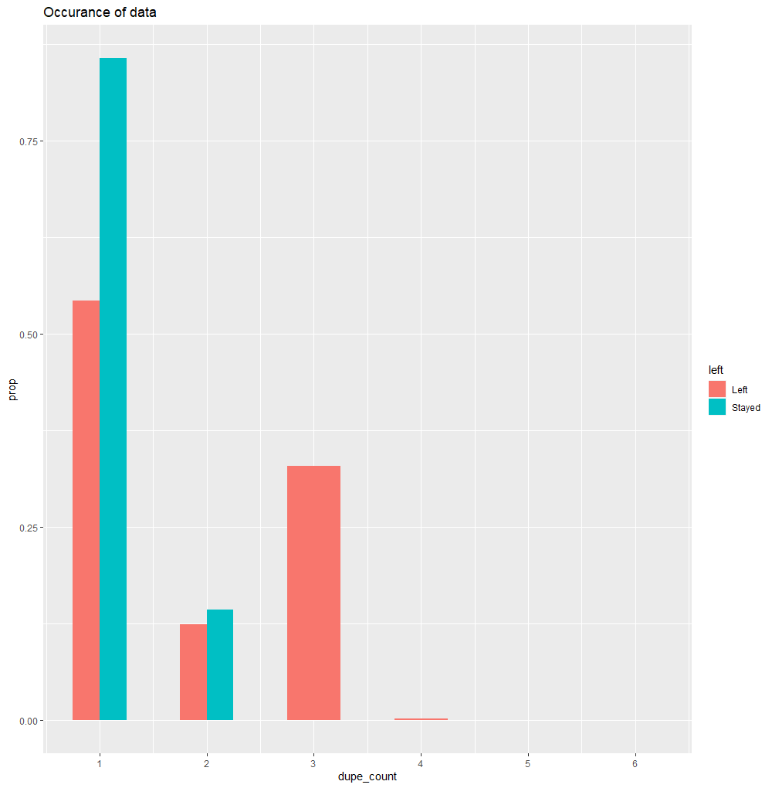
Another issue that the data scientist team points out is the target variable, left, is unbalanced. Before the removal of duplicated data, they collected 11428 and 3571 data points relating to employees not leaving and leaving the company respectively. If I remove the duplicated data, the dataset reduces to 10000 and 1991 respectively. In terms of probability, the data set contains 83.4% for remainers, while 16.6% for leavers, which is a severe imbalance dataset. However, they have not proposed any improvements to the dataset and assume that less than 10 times difference is reasonable.
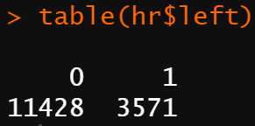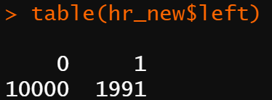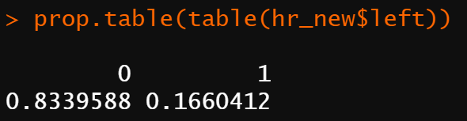
Under-sampling and oversampling are the 2 ways to solve this issue. The first method attempts to decrease the data points for ‘stayers’ such that it matches the data points for ‘leavers’. The second method attempts to create extra data points for ‘leavers’ using artificial points to match with ‘stayers’. Both methods do have weaknesses. The first method causes a reduction of data points, while the second method will be based on assumption through extrapolation of the existing dataset.
If the data scientist team would like to reconsider re-sampling the dataset, I propose to use both oversampling and under-sampling the data. This would not result in removing a lot of the data collected, while at the same time keeping the extrapolation at the minimum. For example, the data scientist team can set leavers and remainers to approximately 50% and come out with a new value of 7548 and 7451 for remainers and leavers respectively. However, as this critique is to analyse the existing report made by the data scientist team, I will not proceed with my suggested method.
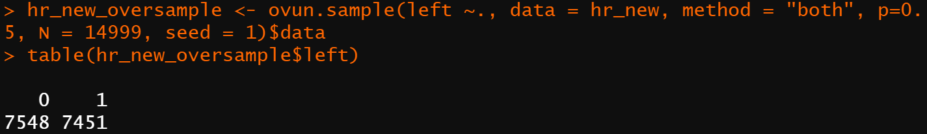
Moreover, oversampling and under-sampling changes the dataset. My recommendation to the data scientist team would be to get a nearly equal amount of data points for the target variable if a similar analysis is conducted next time.
Modelling
  - Modelling assumption
Throughout the whole report, the data scientist team uses the decision tree and random forest to classify feature importance. They have created 2 training sets but fail to create testing set to test their training set. Their dependencies on 2 training sets are likely to lead to overfitting, meaning that their model fits too well with their training set.
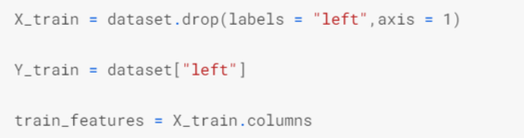
  - Model description
To create a better model, I have decided to split the dataset into testing and training set using original data provided as a demonstration (see Appendix C). I selected 80% of the data for training and 20% of the data for testing. Thus, the training set includes 11933 pieces of data points, while the testing set includes 3066 pieces of data points.
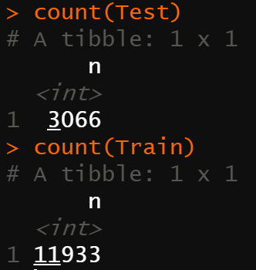
Then, I will then use a random forest model to predict the feature, left.
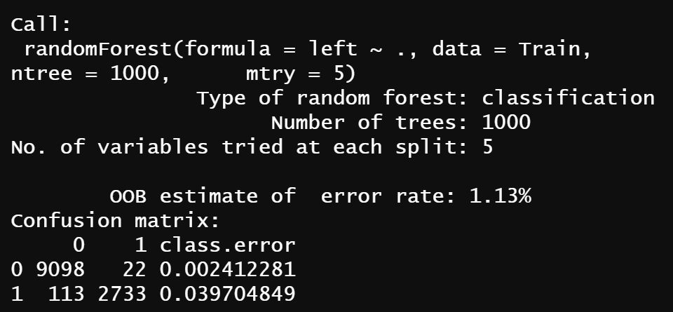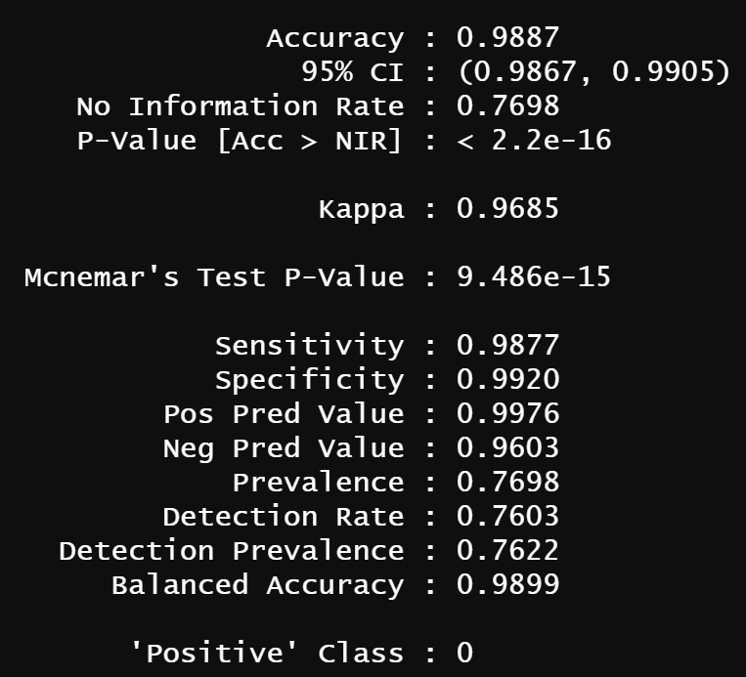
The random forest model shows an astonishingly result with an out of box error rate of 1.13%, which is very low. Furthermore, the dataset has an accuracy of 98.87% with a 95% confidence interval bounded at 98.67% and 99.05%, which is decent. Relating to the sensitivity and specificity, findings suggest the values of 98.77% and 99.20% respectively, meaning it is better at predicting employees staying in the company. As acknowledge that the original dataset is unbalanced, thus the dataset would be more inclined to employees staying in the company.
  - Model assessment
To further illustrate the accuracy, I will be using the ROC plot to demonstrate the accuracy of the dataset.
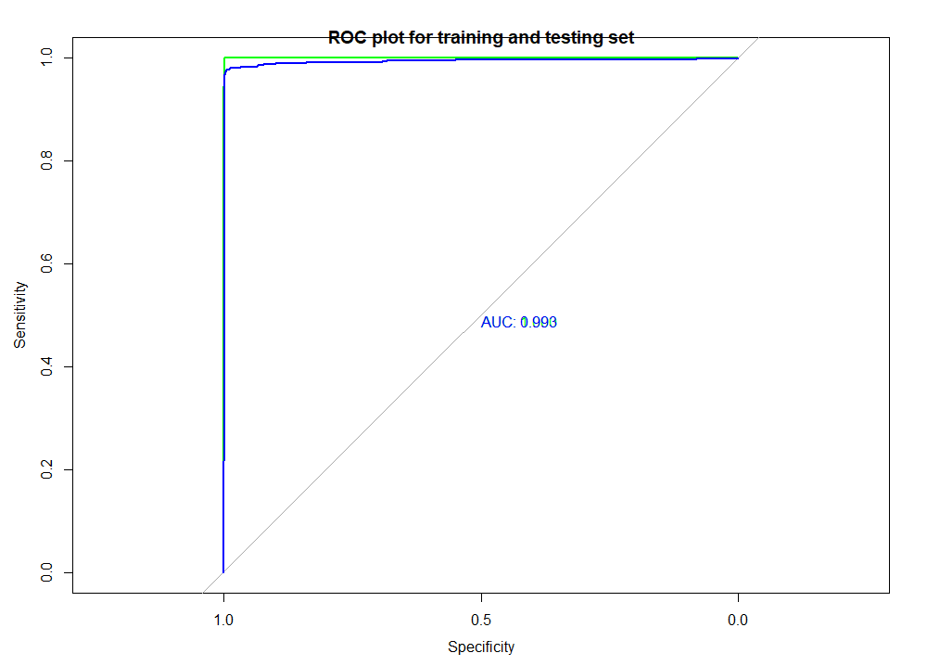
Findings suggest that the testing set has an area under the curve of 1, while the training set has an area under the curve of 0.99. I would say that this model would be very accurate in predicting the dataset.
Using the random forest model, I am also able to identify variable importance.
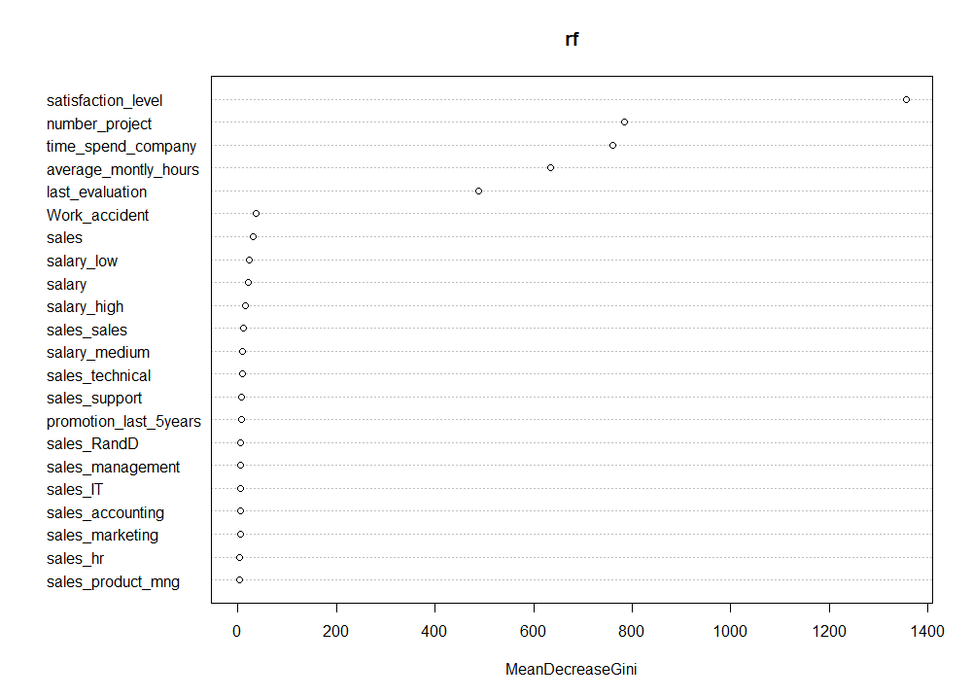
Similar to the report created by the data scientist team, this diagram suggests that satisfaction level would be the most important variable that employees consider when deciding to leave the company, while promotion in the last 5 years is the least important variable for employees leaving the company. This result would also be in line with our PCA bi-plot in our data understanding section
Lastly, I’ve also used the random forest model to predict the most important variable, satisfaction level, and the probability of leaving.
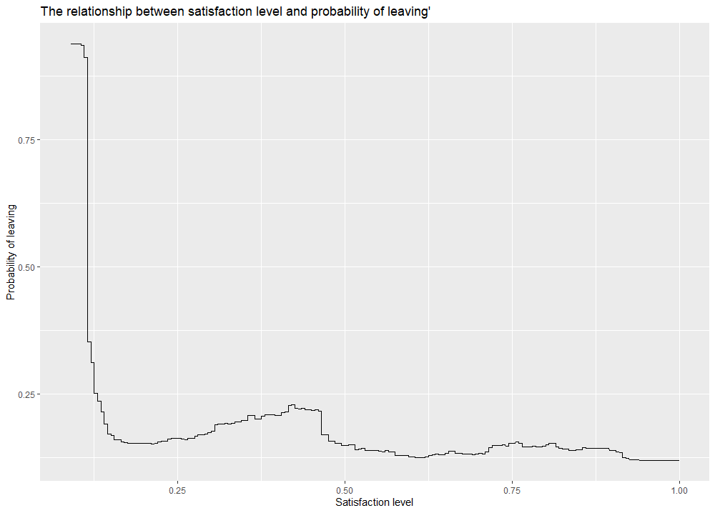
Findings suggest that employees who have a satisfaction level of less than 12.25% have a 25% or more chance of leaving the company. Likewise, the dataset states that there are only 918 employees who have a satisfaction level of less than 12.25%, which is about 6% of the surveyed participants (see Appendix D).

Evaluation
  - Assessment of data mining results with respect to the business problem
Before the data mining results, the visualization in the data exploration section, hazard ratio, suggest that other than the feature relating to salary, most of the features do not have an effect on employees leaving the company. However, with the creation of the random forest model, analysis demonstrates employee’s satisfaction over other variables. Thus, the most important variable that led to the leaving of employees identified by the data scientist team matched my findings.
Satisfaction level would be a variable that lays in my expectation because it takes into overall account of all of the variables provided in the dataset. Consider what makes employees happy about their job, it includes workload, working time, wellbeing, and salary. In other words, the satisfaction level would be the sum of all features listed in addition to features lacking which I have mentioned in the data understand section.
  - Review of process
Comparing the data scientist team and my process, the data scientist uses an additional model in predicting the most important variable. On the other hand, my process relies on an in-depth exploration of 1 single model due to word limits. I strongly believe that my model would be more effective compare to the data scientist team because of 2 reasons. Firstly, my model divides the dataset into 80% for training and 20% for testing, so that the issue of overfitting would be avoided. Secondly, I’ve uses tools such as confusion matrix, ROC curve to check the accuracy, specificity, and sensitivity of the random forest. If such checks are not conducted, there is a higher risk of creating a model that is inaccurate or has many type 1 or type 2 errors.
My suggestion to the data scientist team is to seek to validate the model before getting to the results.
  - List of possible actions
Even though we have derived that satisfaction level would be a key feature that leads to employees leaving the company. However, I would suggest uses to add-on further analytics and data to validate our findings.
One suggestion would be the use of text analytics, which uses text to produce predictive analytics. Even though text analytics is still in the research phase, it still produces insights into our findings. For example, we can use topic models, which identifies key terms and assigned them into topics. The more frequent that the words on a particular topic come out means that the higher issue with that topic. This model would be useful in quickly predicting employee’s satisfaction. It will also help the top management to come out with strategies base on these topics.
As pointed out in the data understanding section, the data scientist team should also collect data relating to the psychological aspect of the employee. It would be an alternative method of understanding the satisfaction and happiness of the employee.
Deployment
  - Deployment plan
In comparison with the findings of this project and the cost-benefit analysis, I would argue that using data mining to find the most important feature that led to an employee’s resignation does not provide a lot more advantage base on an individual’s heuristics. As discussed in the evaluation section that satisfaction level consists of every single factor that employees experience in the company, no doubt that this feature would be the most important variable.
To make use of data mining in this project, I suggest reconsidering the feature variables such that it does not make it seem obvious to guess. For example, psychological factors, comments by employees would be harder to guess using simple heuristics. Besides, the data scientist team should understand that this analysis is an ongoing process. Meaning the more survey’s that the team gets, the better the predictability of the most important issue that leads to employees leaving the company. Therefore, they should make sure that the datasets are up to date from time to time.
Lastly, the model that I have created in this critique uses the original dataset as a demonstration, the whole model would be more inclined to remainers than leavers. For deployment, I suggest using the newly created data set in data preparation, which compose of both oversampling and undersampling.
  - Reviewing the project
This critique looks into the reasons that lead to the departures of talent inside the companies by comparing the report created by the data science team and my own set of visualizations and model. Current findings suggest that satisfaction level would be the most concerning feature variable that leads to employees leaving the company. Thus, to reduce employee’s leaving the company, we suggest the company’s top management to find out ways to increase employee’s satisfaction. However, it is apparent that this analytic would be an ongoing process, this means that new data points would make slight changes to our findings. If time permitted, further analytics including adding new feature variables, the inclusion of text analytics should be conducted to validate our findings.
Appendix A
Survival Model Console
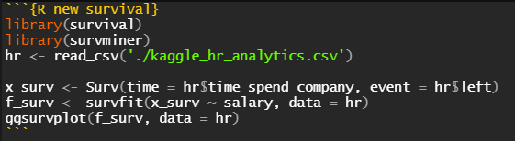
Appendix B
Harzard Ratio Model Console
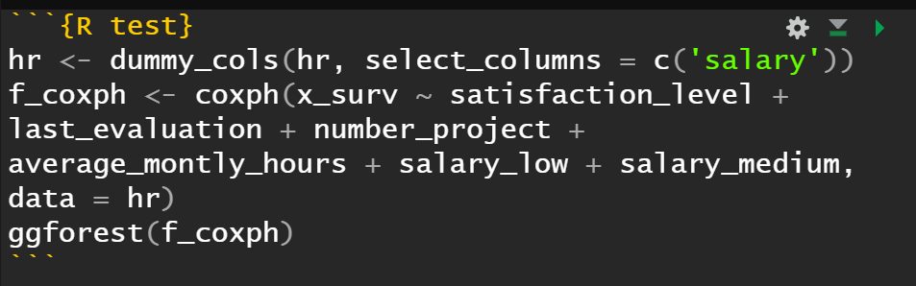
Appendix C
Creating a testing and training set
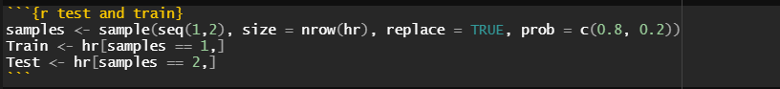
Appendix D
Percentage of employees unsatisfied
